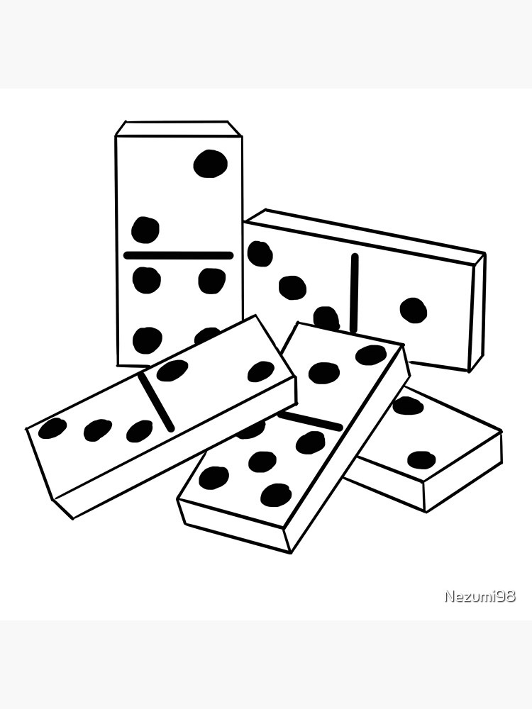
NORTHUMBERLAND FEDERATION OF WIs
ARTS & LEISURE COMMITTEE
DOMINO COMPETITION 2027

Sign up now for 2027’s competition. An excellent opportunity to spend an afternoon / evening meeting ladies from other WIs in far flung corners of Northumberland!.
- Teams of 4, can be more than 1 team per WI.
- No prior experience required.
Get in touch for details if you would like to enter for the first time.

COMMITTEE: EVENT:

Date | Matches played from March to Sept | Cost | £10 per team (to cover admin & supper for the finalists in September)
Closing date for entries: 2nd February 2027 |  | Event code: |  | 2701

Methods of payment:

- WI BACS using the above Event Code (e.g. for an application for 1 member, please use the payment ref 26**x1). In addition, please send a timely corresponding email confirming the BACS payment including your WI name to federationoffice@northumberlandwi.co.uk . Ideally please also provide a scanned copy or photo of this form attached to this email or if unable to do so please additionally type out all the above required details. If these steps have been followed it is not necessary to also post your form to Cresswell House.

Lloyds Bank, Northumberland Federation of Womens Institutes, Sort Code: 30-93-71 Account Number: 03511958.

- Cheques are payable to Northumberland Federation of WIs and sent with a completed copy of this form.

- Other options are to come into the Office to pay by cash or card using our SumUp machine during Office opening hours (Tuesday, Wednesday & Thursday 09:30 – 14:30). Please also complete this form.

Notes:

- Please ensure all applicants and their WI keep a note of event details, particularly if handing in this form.
- Dietary requirements should be completed for any events with food.
- For any additional relevant information that we need to be made aware of for an event please contact us.

..................................................... ............................................................................................................

EVENT CODE 2701 - DOMINO COMPETITION 2027 c/d: 2ND FEB 27

WI Name:
Number of teams @ £10 per team :
Main Contact  Name: |  |  |  | 
Person to be contacted with event updates or if applicants are unsuccessful. We ask that they then update all above members.
Please add both phone and email details where possible.

We look forward to seeing you at this event soon!

